Attention teachers!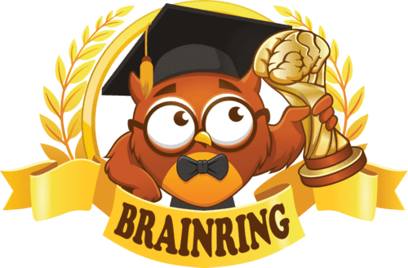

**We invite you and your students to take part in the International Educational Competition for students in grades 1-11 "Brain Ring 2023 - Autumn Session".**

🗓️ **Participation in the "Brain Ring 2023 - Autumn Session" competition is available at any time from 1 to 30 November 2023 inclusive.**

🌟 **6 competitions in various subjects: English, Maths, Science, Computing, History, Geography.**

🎯 **The contest goal is to stimulate students' interest and increase motivation to study.**

📚 **The tasks of varying difficulty correspond to the school curriculum.**

🕒 **40 minutes to complete all tasks (1 lesson).**

🏆 **All participants will receive personal diplomas, certificates and "Brain Ring" pens. They will also be able to win other valuable prizes!**

💵 **Teachers-supervisors of the competition receive certificates of the organiser and a compensation of 30% of the fees of the students they have registered.**

🥇**All teachers whose students have obtained 1-3 degree diplomas receive certificates confirming their students' achievements.**

🏡 **Students can take part in competitions at any time that suits them, not only at school but also at home.**

🖥️ **Participation in the competitions takes place on the website www.brainring.co.uk**

💰 **One student's participation fee in all competitions — £4.99**

🔗 **Registration and further information: www.brainring.co.uk**