Dear Administration,

We would like to invite students and their teachers from grades 1-11 from your school to participate in the **International Educational Competition "Brain Ring 2023 - Autumn Session"**.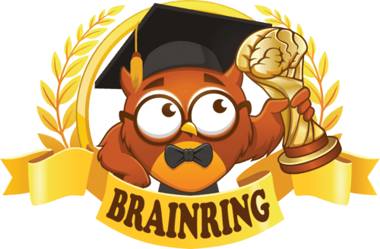

Educational competitions will be held from 1-30 November and cover the following **6** subjects: English, Maths, Science, Computing, History, Geography.

The main goal of the "Brain Ring" competition is to increase pupils' interest and motivation in the subject. Unlike Olympiads, the competition includes tasks of different levels of difficulty, allowing all pupils, regardless of their level of preparation, to demonstrate their knowledge and skills. Sample tasks can be found in the demonstration version of the competitions at [www.brainring.co.uk](http://www.brainring.co.uk)

**Each participant** receives a personalised printed diploma and a branded "Brain Ring" pen.

Teachers-supervisors of the competition receive certificates of the organiser and a compensation of 30% of the fees of the students they have registered.

All teachers whose students have obtained 1-3 degree diplomas receive certificates confirming their students' achievements.

***Please inform students and teachers about the “Brain Ring” competition in the following ways:***

* *Post an announcement on the notice board.*
* *Post another notice in the teachers' lounge.*
* *Publish information about the competitions on the school website.*
* *If the school uses an e-diary, inform teachers, pupils and parents.*

"Brain Ring - Autumn Session" competitions will be held from 1-30 November on [www.brainring.co.uk](http://www.brainring.co.uk). Participation can take place at any time that is convenient for teachers and students.

"Brain Ring" competitions are held remotely, so students can participate at school as well as at home.

If you have any questions, you can always contact us at: [info@brainring.co.uk](mailto:info@brainring.co.uk)

The cost of participation of one student in all competitions is **£4.99**. This fee can be paid by the students or by the school.

*Benefits of "Brain Ring" competitions:*

* *All participants receive personalised printed diplomas and souvenirs.*
* *Free prize delivery.*
* *Detailed report for analysis of student mistakes.*
* *Teachers receive certificates and compensation.*

Compensation for competition supervisors

The organisation of the "Brain Ring" distance competitions is impossible without the extensive support and active participation of the teacher-curators. We know that this process does not come easily and involves several steps - from informing the school and classroom, to collecting registration fees, to the careful organisation of the competitions. This requires a lot of time and attention, especially when mentoring a large group of students.

We want to compensate you for your efforts in organising and running the competitions, and up to 30% of the registration fees collected will be used as financial support for the tutors.

|  |  |
| --- | --- |
| **Number of students** | **Compensation amount** |
| **1-9** | 5% |
| **10-24** | 10% |
| **25-49** | 15% |
| **50-74** | 20% |
| **75-99** | 25% |
| **100 and more** | 30% |

The amount of the compensation depends on the number of registered participants. The more participants you register for the competition, the higher the amount of compensation paid.

Yours sincerely,   
Organisers of the "Brain Ring" Educational Contests  
E-mail: [info@brainring.co.uk](mailto:info@brainring.co.uk)

For more information about the competitions – [www.brainring.co.uk](http://www.brainring.co.uk)